

Navigation aid for person with vision impairments

**CS4921 Computer Science Project I**

By

Htoo Aung Hlaing

2 May 2017

Acknowledgements

I would like to express my very great appreciation to Dr. Lin Min Min Myint for his valuable and constructive suggestion during the planning and development of this senior project. His willingness to give his time so generously has been very much appreciated.

I would like to thanks others professors of SoIT for letting me do this work and believe in me to do this project.

Abstract

Vision is the most important part of human physiology as 83 percent of information being get from the environment is by the light. Navigation Aid for Person with Vision Impairment is about project that will help the blind people in the world to get a better access to the environments. This project provides alert system through vibration or the sound system by using cane, 1sheeld, Arduino programming, ultrasonic sensors and the vibration motors. Nowadays, when the blind person wants to goes out they prepared a guide dog, relatives, white cane or assistive technologies. This project is an assistive technology with consist of two ultrasonic sensors (above and the ground) mounted on the stick or a cane and a vibration motor with will also mounted on the stick. 1sheeld will mounted on the Arduino board for the navigation process for the used of GPS/GSM shield.

**Keywords:**  Arduino, ultrasonic sensor, blind navigation, microcontroller, 1sheeld.

Table of Contents

**Title Page**

Acknowledgements ii

Abstract iii

Table of Contents iv

List of Figures v

Chapter 1 Introduction 6

1.1 Problem Statement 7

1.2 Objectives 7

1.3 Scope of the Study 7

1.4 Expected Benefits 8

1.5 Project Organization 8

Chapter 2 Literature Review 9

2.1 Voice Recognition and Voice Navigation for Blind 9

2.2 How to Make a Smart Cane for the Visually Impaired with Arduino? 10

2.3 RFID Information Grid for Blind Navigation and Way Finding 11

Chapter 3 Methodology 12

3.1 System Design 12

3.1.1 Hardware Description 13

3.2 Project Plan 15

3.2.1 System Workflow – Phase (1) 15

3.2.2 System Workflow – Phase (2) 16

3.3 Gantt Chart 17

Chapter 4 Conclusion 18

References 19

List of Figures

**Title Page**

Figure 1. Prototype Design of the System 9

Figure 2: Items Used for Smart Cane 10

Figure 3: Smart Cane 10

Figure 4 Block Diagram of the System 12

Figure 5 Ultrasonic Sensor HC-Sr04 13

Figure 6 Arduino UNO R3 13

Figure 7 1Sheeld(Arduino Shield) 14

Figure 8 Use of 1Sheeld 14

Figure 9 Flowchart Phase (1) 15

Figure 10 Flowchart Phase (2) 16

Figure 11 Project Plan Showing with Gantt Chart 17

# Introduction

Vision is the most important part of human physiology as 83 percent of information being get from the environment is via the light. Good vision is a precious gift but unfortunately loss of vision is becoming common now a day [6]. According to the World Health Organization (WHO), there are about 39 million people who are blind and 246 have low vision in the world. Recent 2014 statistic made by WHO, shows that 82 percent of people living with blindness are aged 50 and above [5]. Blindness may result from a disease, injury or other conditions that limit vision and because of which blind people confront a number of challenges everyday.

The biggest problem for the blind people is travelling alone or lost confidence in the middle of the sighted people or crowded location due to their disability when trying to figure out their direction to get their destination. They need to be familiar with the environments to avoid the accident. Sometime they need to use so much of tools and technique to help them in their mobility. Some use a guide dogs which are trained specially for the blind people to help their mobility to guide their way and alert the blind person to avoid from the obstacles. However, the cost of the guide dog is very expensive and most of the blind people cannot effort for that price and these dogs are only suitable for limitation of the dog life may be around 5 to 7 years. Nowadays the technologies are become smarter and smarter so that some people use the smart cane which can provide preloaded maps, wireless charging and some others features. Because of its features used, that could be also very expensive.

When 5 students from the Helwan University invented invented and produce 1Sheeld in 2013, it was better to do such kind of works to be done with a short period of time. 1Sheeld is an additional board that can turn any smart phone like Android/iOS smartphones into a sensor or GPS in the real world. By using the 1Sheeld, cost become very low and reduce the item list that need to use in this kind of project. To use the features from the 1Sheeld, the Arduino board and the 1Sheeld board need to be mounted together and to activate the 1Sheeld, download the 1Sheeld application from the Play Store or Apple Store according to the choice of the inventor. The advantage of using 1Sheeld is that there is no more cost for the additional items.

## Problem Statement

The growth of the technologies is become higher and higher day by day, the tools and system that help blind people are become vary. The cost of the systems and cost are also raise. However, the tools and system are become smarter and smarter the traditional white cane is still the number one choice among blind people because of its cost is low. Even though there may be a lot of similar systems which are smarter than this system, their price is still high. One of the main problem of the virtual impaired people have very low income sometime no income. So that the white cane which will use Arduino and 1Sheeld will help them with low cost.

## Objectives

The main objectives of the system are;

1. To do more research on aided devices for the visually impaired person.
2. To Design the aided device for blind.
3. To study how GPS navigation technology works.
4. To study Arduino technology.

## Scope of the Study

This project focuses on developing a blind navigation system which:

* Arduino Uno R3 controller will use.
* Two ultrasonic sensors are mounted on the white cane to detect the obstacles.
* Vibration motor will be mounted on the gripper of the white cane.
* Sound alert or vibration alert to the blind using 1sheeld and vibration motor.
* In this semester I am going to focus only on detecting the obstacles and feed back to the blind by using sound/vibration alert system. The flow chart is provided in the methodology section as phase 1.
* In the second semester I am going to focus on the GPS navigation system for the blind to get their destination by using 1Sheeld and the android smartphone. The flow chart is provided in the methodology section as phase 2.

## Expected Benefits

1. To help the mobility of the blind people
2. Protect the blind people from the obstacles and the dangerous areas.
3. Because of its less cost, most of the blind people can be afford.

## Project Organization

Each chapter’s goal is described and arranged as below;

CHAPTER 1

In this chapter, introduction, objective, scope of the project and expected benefits parts will be included to get the better understanding of the project by explaining generally.

CHAPTER 2

All data collection will be included in Chapter 2 such as theories, similar projects ideas and possible solutions.

CHAPTER 3

This chapter is the most important part of the whole report. In this chapter, how the system will be implement and each necessary parts will be used in which part. And the prototype system model will be show in this part too.

CHAPTER 4

This chapter will be concluding all about this project, what have been done and the future works.

# Literature Review

This chapter presents all the sources from international journals and projects related to this project. This chapter will be covering 3 different types of research about the blind navigation systems that are produced in long time back.

## Voice Recognition and Voice Navigation for Blind

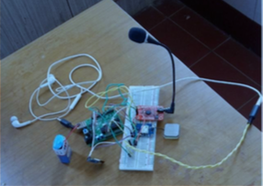

Figure 1. Prototype Design of the System

In this paper, they present the design of the voice based navigation system for blind using voice recognition module and GPS module implemented on Arduino board [6]. This system helps the blind person to navigate. User have to give the destination’s name as the input to voice recognition module. GPS module continuously receives the latitude and longitude of the current location. GPS compares it with the destination’s latitude and longitude. The system compares the destination with the stored locations in the database and select the latitude and longitude of the destination location.

The navigation directions are stored in the SD card in audio format. The blind person will then hear the directions stored in SD card with the help of head phone. The blind person receives the pronounced directions which he needs to follow to reach his destination.

This system is designed and devised to help the blind people to navigate safely and independently [6].

The disadvantage of this system is:

* Using multiple modules to set up.
* Not complete the design part.
* Cost is still higher.

## How to Make a Smart Cane for the Visually Impaired with Arduino?

The smart cane use just 9-volt battery to give the power to Arduino. The

power produced will be used by the one vibration motor, Arduino controller and 1 ultrasonic sensor. When the obstacle detected by the ultrasonic sensor the signal will be sent to the controller and the controller will be deliver that signal about the obstacle distance to the vibration which is mounted at the white cane. This type of warning system is a good choice as it uses human sense of touch and therefore the fastest way to alert them. One best advantage of this system is using the cheapest items. The vibration motor is also from the old mobile phone which every may have.



Figure 2: Items Used for Smart Cane



Figure 3: Smart Cane

## RFID Information Grid for Blind Navigation and Way Finding

An information is based on passive, low-cost, high frequency RFID tags is

installed under the flooring and used to convey precise location and detailed attributes about the surrounding areas [8]. In the university environment, RFID tags can be installed along outdoor pathways, in building hallways and in rooms. By storing all information in the RFID tags about the surrounding space, dependencies on a remote spatial database is not required or the need for wireless infrastructure to support a connection to the database [8]. The base RFID information grid can provide the foundation of precise indoor/outdoor location for the blind user, aid in automated navigation for electronic wheelchair users, and supports service robotics that can use the RFID tags to determine exact location [8].

One disadvantage of this system is that it can only useful all the function in limited area such as school, home and so on.

# Methodology

This chapter describes the proposed architecture for developing system. Important tools and techniques used in the development are also discussed.

## System Design

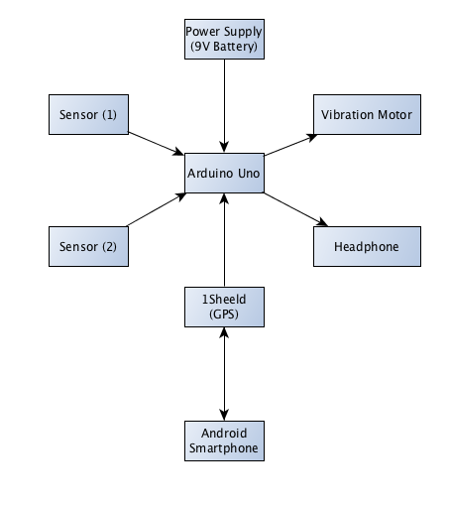

Figure 4 Block Diagram of the System

In this system design, the blind person has to carry the white cane with him. The two ultrasonic sensor will be place on the stick such a way that in front one is in downward and another is in upward. When the obstacle will come in front of the blind person then the ultrasonic sensor sense the presence of the object after that Arduino will processed further and this system will alert to the blind by the vibration from the vibration motor.

This stick having 1Sheeld device which have to mounted on the Arduino as a shield to use the GSM/GPS navigation module which is used to track the exact location of the blind.

### Hardware Description

1. *Ultrasonic Sensors*

To detect the obstacles and avoid from them the ultrasonic sensor has to use. Ultrasonic ranging provides 2cm-400cm non-contact measurement function, the ranging accuracy can reach to 3mm. The ultrasonic sensor sends out a high-frequency sound pulse and then times how long it takes for the echo of the sound to reflect back.

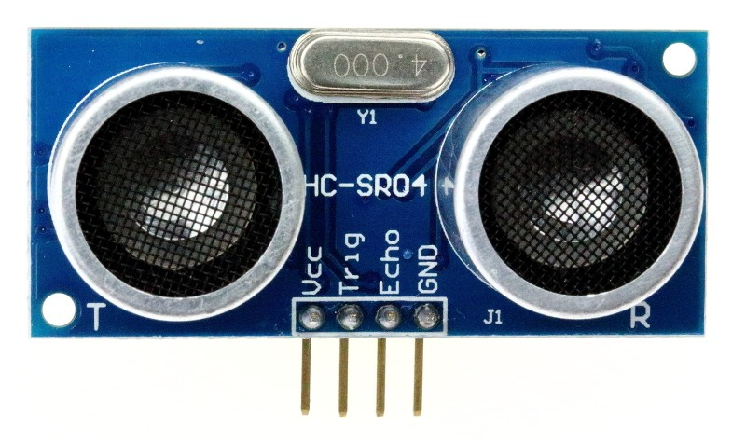

Figure 5 Ultrasonic Sensor HC-Sr04

The sensor has 2 opening on its front. One opening transmits ultrasonic waves, the other receives them. In order to determine the distance to an object, it is necessary to implement a timing loop in the microcontroller code to measure the length of time required for the sound wave generated by the emitter to traverser the distance to the object.

1. *Arduino UNO R3*

Arduino is a single-board microcontroller, intended to make the application of interactive objects or environments more accessible. The hardware consists of an open-source hardware board designed around an 8-bit Atmel AVR microcontroller, or a 32-bit Atmel ARM. Current models feature a USV feature a USB interface, 6analog input pins, as well as 14 digital I/O pins which allows the user to attach various extension boards.

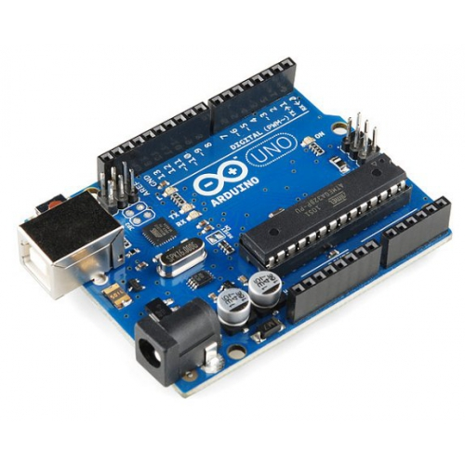

Figure 6 Arduino UNO R3

It contains everything needed to support the microcontroller, simply connect it to a computer with USB cable or power it with a ac to dc adapter or battery to get started.

1. 1Sheeld

1sheed is a new configured shield for Arduino. It is connected to a mobile app that allow the usage of all of android smartphones capabilities such as LCD Screen, gyroscope, switches, LEDs, accelerometer, GSM, Wi-Fi, GPS and etc. into the Arduino Sketch.

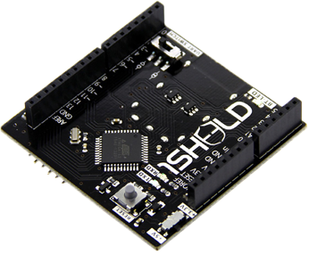

Figure 7 1Sheeld(Arduino Shield)

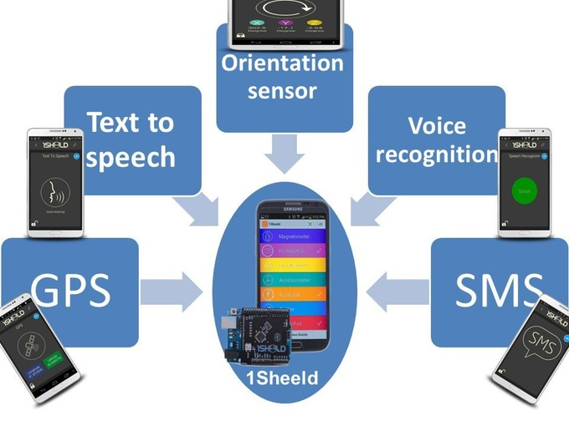

Figure 8 Use of 1Sheeld

By using that 1Sheeld can act as input or output from the Arduino and make use of all of the sensors and peripherals already available on your smartphone instead of buying the actual shields.

1. *Headphone*

The headphone is used in this project for guiding the visually impaired person to navigate..

1. *Battery*

To work the system, the whole day or limited hours, we need to use the battery (9V) to give the power to Arduino board and others parts that included in the system.

## Project Plan

### System Workflow – Phase (1)

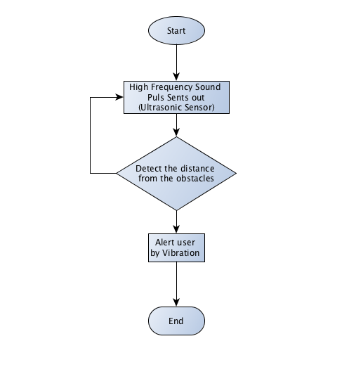

Figure 9 Flowchart Phase (1)

As I have mentioned in the scope of the project in Chapter (1), the system development is divided into phase (1) and (2). The above system flows provide how the system will be going to work in the phase (1). As the blind person turn on the system, the ultrasonic sensor will perform the obstacle detection task. As mentioned above, the two ultrasonic sensors will be mounted in front of the stick which is in position of above and below. One from the above will detect the obstacles which are higher from the ground and another will be focus on the ground, which will detect the obstacles from the ground. The calculation task to calculate the distance from the blind person to the obstacles will be perform by the microcontroller. When the obstacles detect by the ultrasonic sensor, the vibration motor is going to vibrate to alert the user.

### System Workflow – Phase (2)

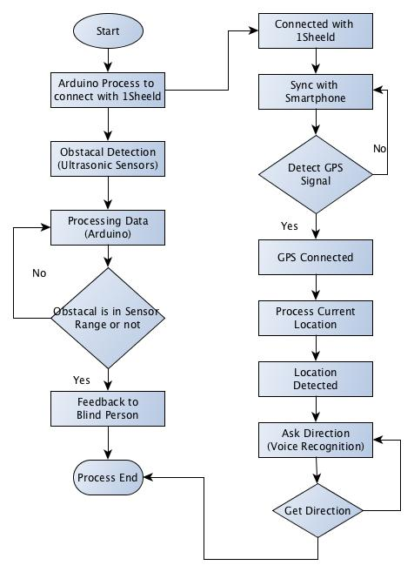

Figure 10 Flowchart Phase (2)

Figure 10 trying to examine that the Phase (2) of the system, which will develop after the phase (1) is complete. In this phase, another module is added to the the system, which will perform the GPS navigation part by mounting the 1Sheeld device, which is the Arduino shield. 1Sheeld can perform as all in one shield which means that you don’t need to buy others Arduino shield. To perform the phase two, the user has to turn on the Android smartphone and sync with 1Sheeld. As it syncs with the system, it will detect the GPS signal by the smartphone. If it can not detect the signal, the system will be performing the smartphone sync step again. Once the GPS signal is connected, the system is going to get the current location of the user. Once this step is complete, the playback system which is perform by the 1Sheeld will ask the user to get the destination to give the direction. When the system gets the destination as a user input, the system will give the direction to the user by the voice recognition module. On the way to the destination, the system will also provide the user to avoid the obstacles by using the two ultrasonic sensors.

## Gantt Chart

In this section, I would like to present my project timeline with the Gantt chart to show clearly my future plans and what I have done in the past.

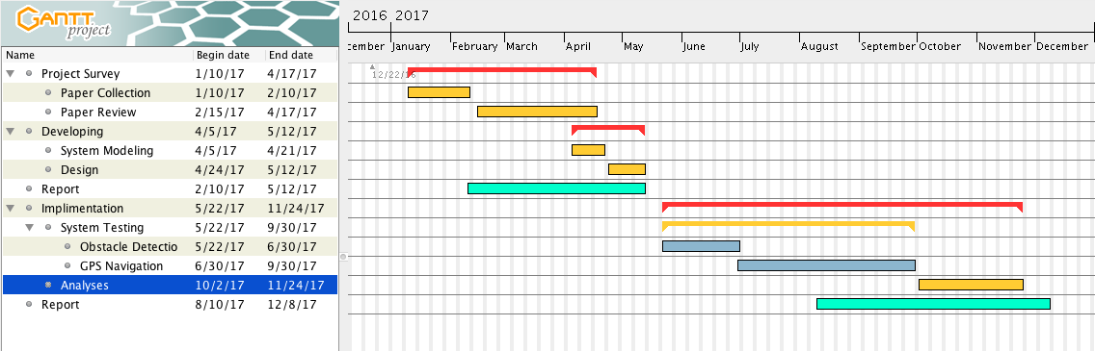

Figure 11 Project Plan Showing with Gantt Chart

# Conclusion

The main purpose of this report is to produce a prototype that can detect objects or obstacles in front of the users and give back the warning back, in the form of sound or vibration to users. Navigation aid for person with visually impairment uses Arduino Uno R3 board as main controller. A simple, cheap and easy to handle electronic system provide guidance to the blind.

This report tries to examine the various issue while building the aided system for the blind people. In this report I tried to review some articles and some journals or books that I got an advice from my advisor and my friends. By doing this report, I came to know what kind of devices and tools should I use.

# References

[1] Sharma, P., Shimi, S. L., Chatterji, S., *Design of Microcontroller based Virtual Eye for the Blind*, International Journal of Scientific Research Engineering & Technology (IJSRET), ISSN 2278 – 0882, Volume 3, Issue 8, November 2014

[2] Bansode, M., Jadhav, S., Kashyap, A., *Voice Recognition and Voice Navigation for Blind using GPS,* International Journal of Innovative Research in Electrical, Electronic, Instrumentation and Control Engineering Vol. 3, Issue 4, April 2015

[3] Nakita, S., T., Rohini, D., W., Shubhangi, V., K., *Sonic Eyes with Walking Stick for Blind People,* IJSRD - International Journal for Scientific Research & Development| Vol. 4, Issue 02, 2016

[4] Visual Impairment and Blindness, *http://www.who.int/mediacentre/factsheets/fs282/en/****,*** retrieved on 22, April 2017

[5] Bohem, K., What Problems do Blind People Face when Living life? *https://www.quora.com/What-problems-do-blind-people-face-when-living-life,* 8, November 2016

[6] Bansode, M., Jadhav, S., Kashyap, A., *Voice Recognition and Voice Navigation for Blind using GPS*, INTERNAITONAL JOURNAL OF INNOVATIVE IN ELETRICAL, ELECTRONICS, INSTRUMENTATION AND CONTROL ENGINEERING, Vol 3, Issue 4, April 2015

[7] Suhail, How to Make a Smart Cane for the Visually Impaired with Arduino, *https://diyhacking.com/arduino-smart-cane-for-the-blind,* retrieved on April 25, 2017

[8] Willis, S., *RFID Information Grid for Blind Navigation and Way Finding,* DOI: 10.1109/ISWC.2005.46 · Source: IEEE Xplore, on November, 2005